TALOSEC INCIDENT RESPONSE REPORT
Incident Identification
- Organization: Talosec
- Case Tracking Code: CORD-202512-AliRayyan-001
- Incident Type:
  - Network Port Scanning (Reconnaissance)
  - SSH Brute Force (Background Activity)
- Incident Status: Mitigation Active – Monitoring Ongoing
- Reported By: SOC Analyst Intern
- Analysis Period: Current Day (24-hour window)
- Affected Asset: server02
- Security Platform: Wazuh SIEM v4.14.1

1. Executive Summary
During SOC monitoring activities, confirmed network reconnaissance (port scanning) was detected targeting server02. Multiple external source IP addresses were observed probing several destination ports within narrow time windows, consistent with automated scanning behaviour.
In parallel, low-volume SSH brute-force attempts continued but were effectively mitigated by previously enabled firewall-drop Active Response. No successful exploitation or system compromise was identified.

2. Incident Description
The incident consists of external reconnaissance activity, where attackers attempted to enumerate exposed services on server02. Such activity is commonly a pre-attack phase preceding exploitation attempts.
The scanning activity was detected through Wazuh alert correlation and destination port analysis.

3. Section A – Confirmed Network Port Scanning
Detection Overview
Multiple external IPs were identified performing multi-port access within narrow timeframes, each port receiving a single connection attempt.

🔹 Source IP (3.227.51.177)
- Ports Accessed: 10 distinct ports
- Timing: All ports accessed at 14:00
- Attempts per Port: 1
Assessment:
This pattern represents a classic horizontal port scan, consistent with tools such as Nmap SYN or TCP connect scans, designed to rapidly map exposed services.
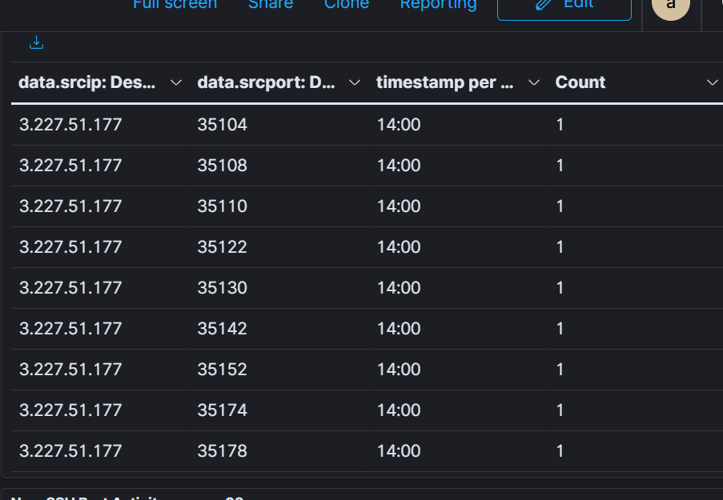

🔹 Source IP (36.212.3.142)
- Ports Accessed: 5 distinct ports
- Timing: Clustered between 00:00 – 00:30
- Attempts per Port: 1
Assessment:
Low-intensity reconnaissance, likely executed in rate-limited or stealth mode to evade detection.
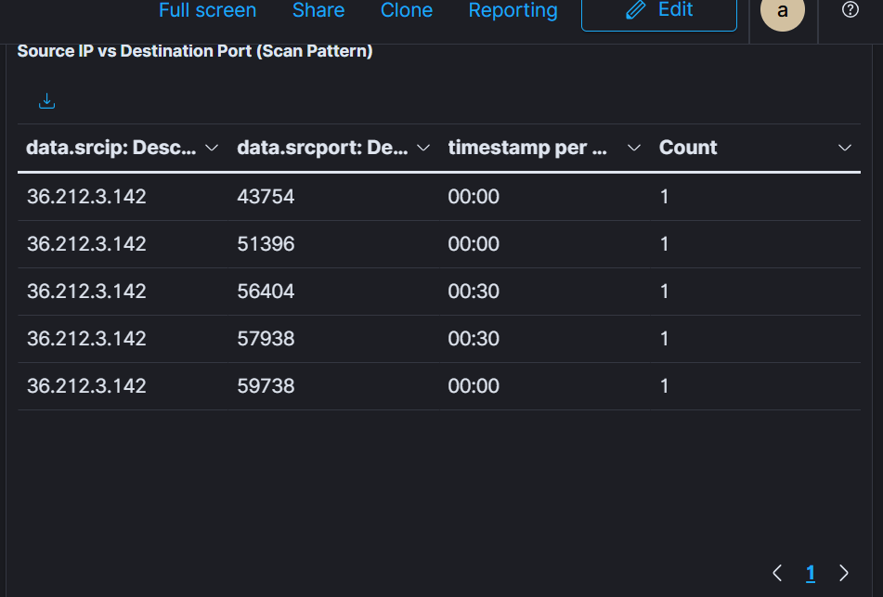

🔹 Source IP (82.67.140.251)
- Ports Accessed: 5 distinct ports
- Timing: All ports accessed at 18:30
- Attempts per Port: 1–2
Assessment:
Reconnaissance behaviour, potentially validating service availability following an initial scan.
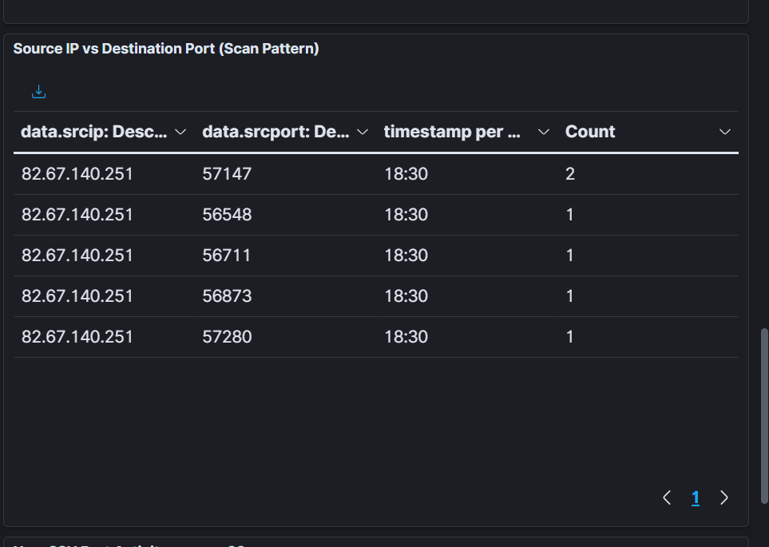

Conclusion (Section A)
The above activities are definitively classified as Network Port Scanning (Reconnaissance). The observed behaviour matches known attacker techniques used to map a target’s attack surface prior to exploitation.

4. Section B – SSH Brute Force (Background Activity)
Detection Summary
- Rule Triggered: 5710 – SSH Attempt to Login Using Non-Existent User
- Alert Volume: Low
- Mitigation: Firewall-drop Active Response
Analysis
SSH brute-force attempts were detected at low volume and were automatically mitigated. Offending IP addresses were blocked immediately, with no sustained attack observed.
Conclusion
SSH brute-force activity remains contained and controlled, posing minimal risk under current mitigation.

5. Mitigation and Response Actions
- Firewall-drop Active Response remains enabled and operational
- Automatic blocking applied to repeated SSH offenders
- Network reconnaissance activity documented and escalated for monitoring
No manual intervention was required during this phase.

6. Impact Assessment
- System Availability: Not impacted
- Data Confidentiality: No compromise detected
- Data Integrity: Preserved
- Overall Risk Level: Medium (Reconnaissance Detected)

7. Recommendations
- Continue monitoring for follow-up exploitation attempts.
- Temporarily block confirmed scanning IPs if repeat activity is observed.
- Review firewall rules to ensure unnecessary ports are not exposed.
- Maintain dashboards for:
  - Destination port activity
  - Source IP reconnaissance trends

8. Incident Status
Current Status: Mitigation Active – Monitoring Ongoing
No escalation required at this stage; however, reconnaissance activity indicates potential future attack attempts.

9. Closing Statement
The detection of coordinated port scanning activity demonstrates effective SOC visibility into early-stage attacker behaviour. Continued monitoring and proactive mitigation will be maintained to prevent escalation into active exploitation.

